Title - SpendWise
Team members
- MONISHA.M (TEAM LEADER)
(monisha.tambaram@gmail.com)
- SNEHA.B
(snehakrishnan1811@gmail.com)
- RISVANA BEGUM.A
(risvanabegum44@gmail.com)
- JEJITHA.M
(jejithamuniraja2006@gmail.com)
- JESHMA JESILY.A
(jeshmajesily2006@gmail.com)

1. Introduction
SpendWise is a web-based expense tracking system that helps users record and manage daily expenses.
Many people find it difficult to keep track of their spending, which may lead to poor financial management.
This application allows users to add, store, and view expense details easily using modern technologies like Node.js and MongoDB.

2. Existing System
In the existing system, many users track expenses manually using notebooks or spreadsheets. This method is time consuming, difficult to maintain, and data may be lost easily. Manual calculation of expenses also makes financial tracking inefficient. Manual expense tracking takes more time and effort. Users must write down every transaction, which can be inconvenient. In addition, calculating total expenses manually can be difficult and time-consuming.Another major problem is data loss. If the notebook is misplaced or damaged, all recorded data will be lost. Spreadsheets also require basic technical knowledge, which may not be convenient for all users.The existing system also lacks proper organization of expense categories. It becomes difficult to track expenses related to food, travel, bills, and other activities. separately.Because of these limitations, a digital system is required to simplify expense tracking and improve financial management

3. Proposed System
The proposed system is SpendWise, a digital expense tracking application.
It allows users to add expense details and store them securely in a MongoDB database.
Node.js and Express handle backend operations and manage the data efficiently. The application stores all the expense information in a MongoDB database. Node.js and Express.js are used to create the backend server that processes user requests and handles data storage.The proposed system offers several advantages. It allows users to quickly record their expenses and retrieve them whenever needed. The system organizes expenses in a structured format, making it easier to analyze spending patterns.The system is designed to be simple, efficient, and user-friendly so that anyone can use it without technical difficulty.

4. System Architecture
The backend layer is developed using Node.js and Express.js. It processes user requests, performs application logic, and communicates with the database. When a user adds an expense, the request is sent to the backend server.The database layer uses MongoDB to store all expense data. MongoDB is a NoSQL database that stores data in the form of documents. The backend server connects to MongoDB using Mongoose to manage database operations.This architecture ensures smooth communication between the user interface, server, and database.
System Architecture Diagram:
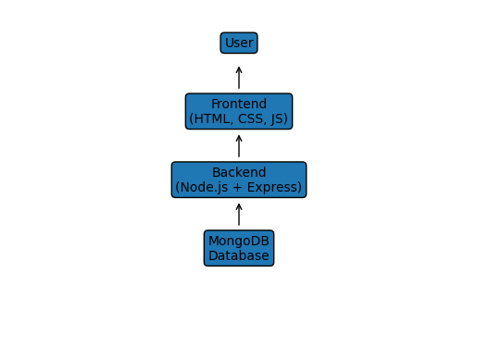

5. System Implementation
The implementation of SpendWise involves developing the backend server, connecting the database, and creating the user interface.First, a Node.js project is created using npm. Required packages such as Express.js and Mongoose are installed. Express.js is used to build the server and create API routes for handling user requests.Next, MongoDB is connected to the application using Mongoose. A schema is created to define the structure of the expense data. The schema includes fields such as title, amount, category, and date.
API routes are then created to perform operations like adding and retrieving expenses. When a user enters expense details through the interface, the data is sent to the backend server and stored in the MongoDB database.The system successfully stores and retrieves expense records, enabling users to monitor their financial activities easily.
Expense Workflow Diagram:
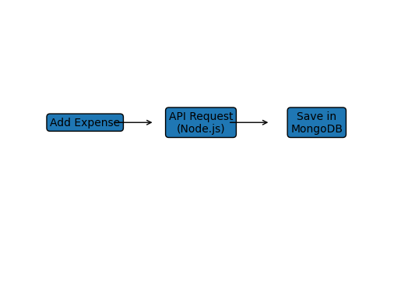

6. Future Enhancement
Although SpendWise provides basic expense tracking features, several improvements can be added in the future.
User authentication can be introduced so that each user can maintain their own expense records securely. Graphical reports and charts can be added to visualize spending patterns. This will help users analyze their expenses more effectively.
A mobile application version can also be developed so that users can track expenses using their smartphones. Budget alerts can be added to notify users when their spending exceeds a predefined limit.
Export options such as downloading reports in PDF or Excel format can also be implemented. These enhancements will make the system more advanced and user-friendly.

7. Conclusion
SpendWise helps users manage their daily expenses effectively.
By using Node.js and MongoDB, the system ensures efficient data storage and fast processing of expense records.

